1. Consider the context free grammar $G=(V,Σ,R,S)$, where

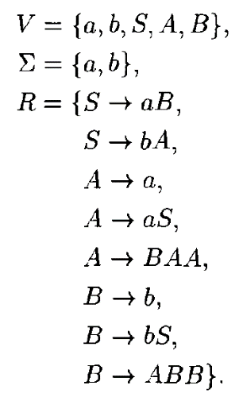

Show that $ababba∈L(G)$.

1. Construct context-free grammars that generate each of these language

a). $\{ww^{R}:w∈{\left\{a,b\right\}}^{*}\}$

b). $\{w∈{\left\{a,b\right\}}^{*}:w=w^{R}\}$



1. Show that the following languages are context-free by exhibiting contextfree grammars generating each:
2. $\{a^{n}b^{m}c^{m+n}:n,m≥0\}$.

$\{a^{m}b^{n}c^{p}d^{q}:m+n=p+q\}$

$\{uawb:u,w∈{\left\{a,b\right\}}^{*},\left|u\right|=|w|\}$

A: i) $\{a^{n}b^{m}c^{m+n}:n,m≥0\}$.

1. Use Pumping theorem to show the followings are not context-free:

a). $\{a^{n}b^{n}c^{n}:n≥0\}$

b). $\{a^{p}:p is prime\}$

c). $\{a^{n^{2}}:n≥0\}$

d). $\{a^{n}b^{n}a^{n}b^{n}:n≥0\}$

e). $\{ww:w∈{\left\{a,b\right\}}^{*}\}$

A:

1. Determine whether the following statement is correct or wrong, and state your reason.

a). Language { $a^{6n}b^{3m}c^{p+10}$: *n* ≥ 0, *m* ≥ 0, *p* ≥ 0} is regular.

b). ***A*** and ***B*** are two context-free languages, so is ***A***⊕***B***, where

***A***⊕***B*** =(***A***−***B***)∪(***B***−***A***).

Q: what if I replace context-free with regular?

c). Language $\{a^{m}b^{n}c^{l}:m,n,l∈Z_{≥0}, m+n>3l\}$ is context free.

d). Language $\{a^{m}{\left(bcd\right)}^{n}:m,n≥0\}$ is not context-free.

e). The concatenation of a context-free language and non-context-free language is non-context-free.

